Merge Conflicts:

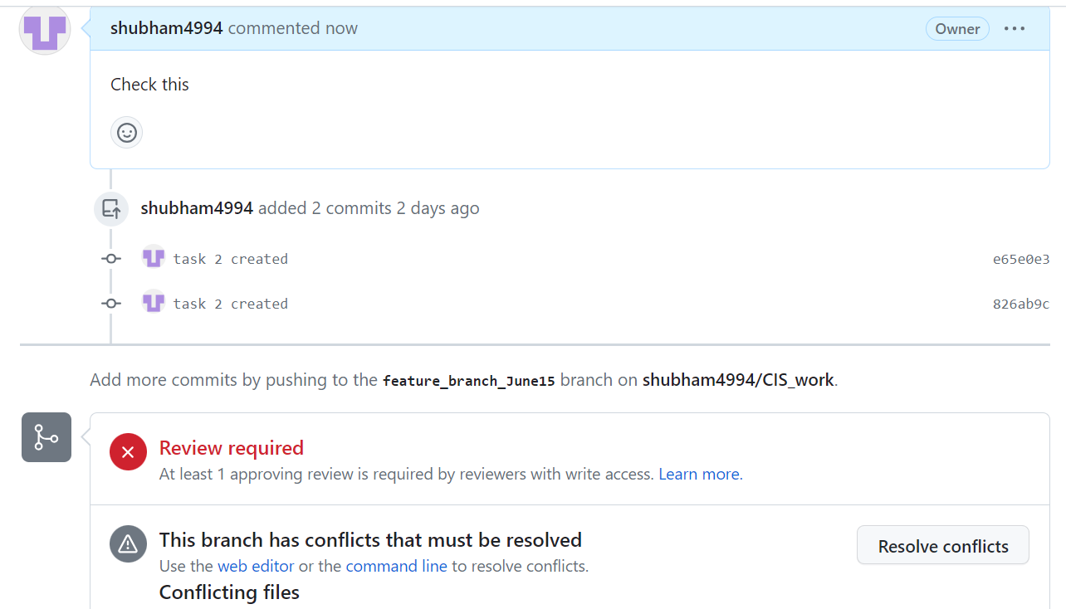

Resolved the conflict

**When I do Git Pull**: It do combination of two commands: Git Fetch and Git merge.  
when you do Git fetch command in your local machine it fetches the latest changes from the remote repository and incorporates them into your local branch  
After Git Fetch you need to do Git merge to merge the changes to your local branch.

Git Rebase and Merge: Git Merge Git creates a new merge commit that combines the changes from both branches. The commit history will show a merge commit indicating the integration of the develop branch into the feature branch.

With Git rebase, Git moves the commits from the feature branch on top of the latest commit of the develop branch. This results in a linear commit history without merge commits.

**Branching Protection Rule**:

After adding branching protection rule, I’m having error but still can merge because I’m the only one user to this account.

